Council’s/Event organiser’s Letterhead

<Contact Name>
<Toilet Hire Company Name>
<Address>

Dear Sir/Madam

RE: ACCESSIBLE (DISABLED) PORTABLE HIRE TOILETS

<Council’s/Event Organiser’s name> is committed to providing equitable access to our products and services for our customers. As part of this focus, we’re committed to providing accessible facilities for people with disabilities at our events.

According to a 2009 survey by the Australian Bureau of Statistics there are four million people in Australia with a disability, which equates to 18.5% of the population and a significant proportion of people who could be attending a planned event. Failure to successfully plan for the needs of people with a disability represents a significant risk to our organisation.

It has been brought to our attention that the portable accessible (disabled) toilets we hired from you on <event date> for <event name> did not comply with applicable Australian Standards relevant to accessible toilets.

Providing accessible public toilets that do not comply with Australian Standard AS1428.1 (2009) - Design for access and mobility, Part 1: General requirements for access – New building work (AS1428.1) leaves <Council’s/Event Organiser’s name> exposed to legal action due to discrimination against patrons with disabilities at our events under sections 23 and 24 of the Disability Discrimination Act 1992 (DDA).

It is therefore important for our organisation to consider the accessibility of the services we provide. As can be seen in the photos below, the current available for hire portable toilets do not comply with Australian standards and will need to be redesigned to comply before our organisation is in a position to use your company’s products again.
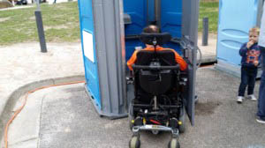
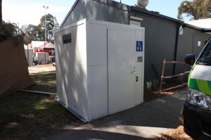

Examples of inaccessible portable hire toilets
Please advise when you have accessible toilets that comply available for our organisation to use.

Yours sincerely,
<Contact name>
<insert position>

